Industrial Revolution 4.0:
An Investigation into the Global Chip Shortage and the Race to Control an Industry

Aaron Ostroff
Independent Study
December 17, 2021
The Covid 19 virus has drastically affected our way of life. Most countries, particularly at the start of the pandemic, were unprepared for the challenges that would inevitably arise when things began to shut down. As a result, many businesses struggled to stay afloat and meet product demand during the pandemic. The worst of the pandemic has passed, but the world continues to struggle. Many industries around the world are concerned about supply chain issues. The global market is still suffering as a result of one industry's inability to meet demand: the semiconductor or "chips" industry. The ramifications of this scarcity are severe. Although the automotive industry was initially the primary source of concern, the crisis has since spread to all smart electronics products. New surges in demand, such as those caused by changing consumer habits, combined with challenges in chip capacity allocation, resulted in a global chip shortage in 2021.
The geopolitical importance of semiconductors is best exemplified by a quote from Martijn Rasser, senior fellow at the Center for a New American Security: ‘Whoever controls the design and production of these microchips will set the course for the 21st century’. This quote could not be more accurate; the entire world is dependent on chips. In order to truly paint a global picture of the semiconductor market, one is to understand the major players involved in this industry. Chips are an essential part of business. Any company that manufactures electronics requires them, and as technology continues to progress, more electronics are becoming smart. This paper looks into the semiconductor industry and its growing importance in the global economy and international trade. This study also investigates the current global chip crisis, determining how the complexities of chip production, geopolitical tensions, and a global pandemic may cause this shortage to last for years.
Global demand
For many years, chip demand has been high, but as we become more reliant on electronic devices in our daily lives, demand is skyrocketing. As a result of the Covid pandemic's supply chain breakdown, demand for chips has become so severe that supply can no longer meet demand, resulting in a situation affecting major technology and automotive companies all over the world, preventing them from producing the much-needed products we require. Global semiconductor sales are expected to reach 552.96 billion US dollars in 2021. The annual growth rate is expected to be 25.6 percent. Figure 1 displays how the semiconductor market size has grown dramatically since 1987
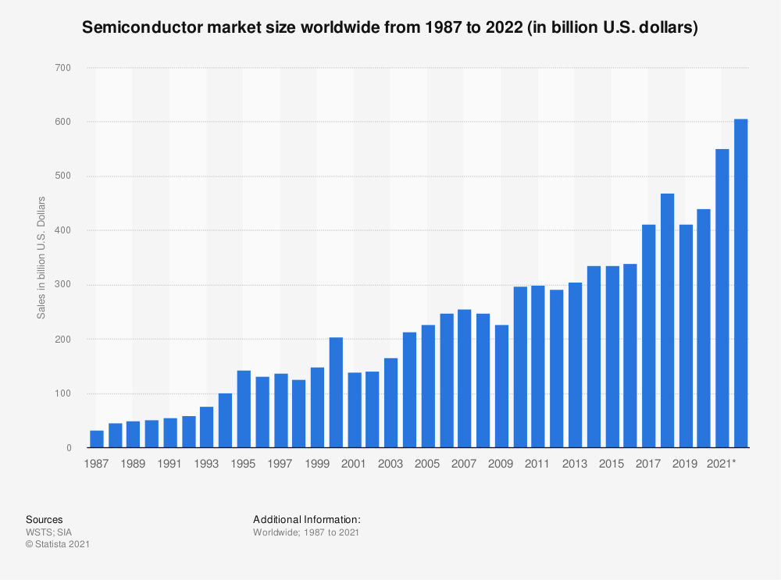Figure 1 (see 4)
Figure 1 depicts the expansion of the semiconductor industry's market size, which correlates with an increase in demand. As technology has become more important in our daily lives, so has the demand for chips. Furthermore, as basic industries continue to improve and digitalize, a greater number of chips for most products has become a necessity. The automotive, communications, and computer industries have all played important roles in the consistent increase in semiconductor demand.
To better understand how reliant the world is on semiconductors, consider how much profit the world's leading semiconductor manufacturer has made from various regions. Figure 2 depicts Taiwan Semiconductor Manufacturing Company's (TSMC) net profit distribution in 2020 by region. As illustrated in Figure 2, the demand for semiconductors is critical all over the world. Given that North America accounted for 62 percent of net profit, they may have the highest demand. Yet, most countries are working to produce their own chips, as will be discussed further in the following section.
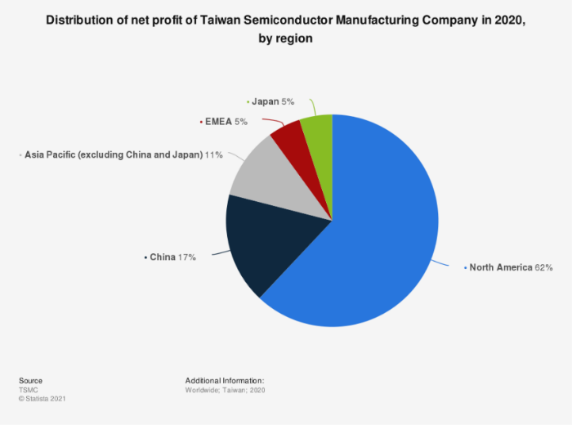Figure 2.
Despite the efforts of many countries/regions around the world to achieve self-sufficiency, they frequently rely on TSMC to supply them with the necessary chips to meet demand. This finding confirms that the global demand for chips is extremely high.
Global supply
According to recent data, global semiconductor expenditures totaled 418.3 billion US dollars in 2019. Apple spent the most money on semiconductors, with 36.13 billion US dollars, while Samsung Electronics came in second with 33.41 billion US dollars. As Figure 3 illustrates below, “big tech” companies spend a lot of money on semiconductors.
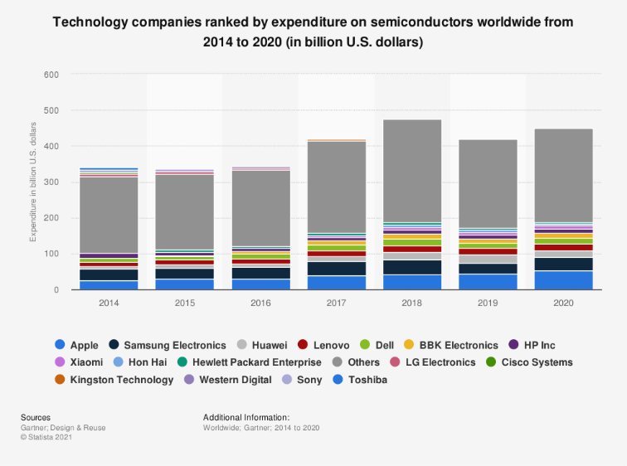Figure 3.
Regardless of how big these technology companies are or where they are based, all of these companies are unable to manufacture their products without spending billions of dollars on chips.
Semiconductor chip manufacturing is a multibillion-dollar industry that is now dominated by Asia, which accounts for 75 percent of semiconductor production, but this was not always the case. For decades, Intel dominated the $400 billion sector by designing the greatest products and manufacturing them in its own cutting-edge factories, often called fabs or foundries. This model has fallen apart in recent years as the corporation has missed deadlines for new production technology, while most other chipmakers have outsourced their designs to 3rd party foundries. 25 years ago, America produced 37 percent of the world’s semiconductor manufacturing, today it only accounts for 12 percent. Pat Gelsinger, Intel’s CEO, has set an ambitious goal of not only catching up with, but also surpassing, Samsung and TSMC by 2025. Key to the plan is a series of massive new chip fabrication plants, or fabs, that Intel is building in the U.S., Europe, and Israel. Combined, they will cost more than $44 billion to build.
Europe’s semiconductor manufacturing is lacking even more than America’s, but there are plans for this to change in the coming years as well. By 2030, the European Union (EU) wants Europe to supply at least 20 percent of the world’s semiconductors in terms of value. Although Europe’s semiconductor revenue is lower than in other regions, it does have important capabilities that could help it meet their ambitious targets. A good example is chip manufacturing for the automobile industry, which is dominated by companies like NXP Semiconductors (Netherlands) and Infineon (Germany). This market also has a good deal of potential crucial for the semiconductor industry, due to fact that ASML (Netherlands), headquartered in Europe, is a major chip-making equipment manufacturer and the sole producer of extreme ultraviolet lithography (EUV) machines.
As previously stated, Asia now dominates the chip manufacturing industry, as illustrated in Figure 4 below. This could be explained in several ways. The first is that Asia has consistently spent the most money on cutting-edge semiconductor equipment, cementing Asia’s position as the home of the vast majority of the world’s foundries.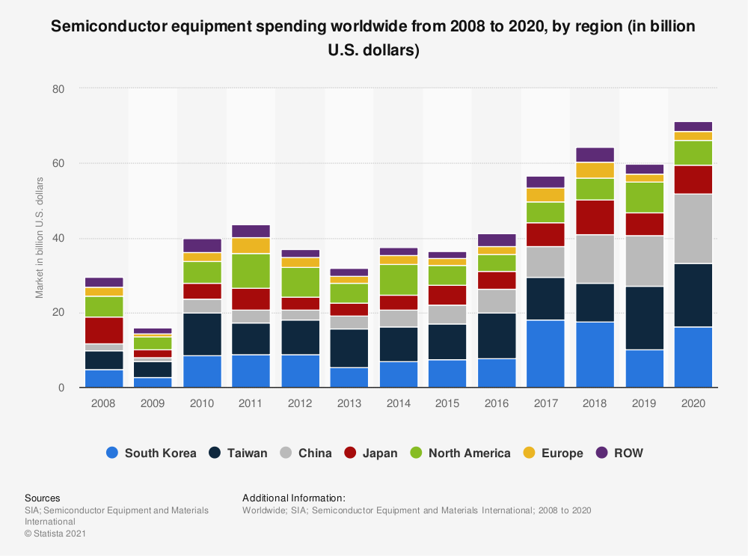Figure 4.
South Korea and Taiwan have consistently outspent their global competitors on semiconductor equipment. Japan also appears to have maintained a fairly significant stake in the industry over the years, as evidenced by the above graph, which shows that in recent years, 2013-2018, Japan has made an effort to expand its semiconductor industry. An interesting finding from this graph is China’s recent increase in spending on semiconductor manufacturing equipment, implying the country’s ambitions to become a self-sufficient chip manufacturer. Nonetheless, Taiwan’s dominance in the chip manufacturing industry is the primary reason that this region is the largest chip producer.
Given that China and Taiwan are major adversaries, it is only natural for China to take the necessary steps to reduce their reliance on them for such critical products. Prior to the pandemic, mainland China devised a strategy for developing a domestic semiconductor industry. Beijing began preparing domestic manufacturers in 2014 with the goal of becoming the world’s largest semiconductor and chip manufacturer by 2030 and supplying 70 percent of domestic demand by 2025. The volume of integrated circuit production has increased from more than 100 billion pieces in 2014 to more than 261 billion pieces in 2020. The current chip shortage will only add to the pressure on manufacturers to meet these targets.
As a result of China’s trade war with the Trump administration, the Semiconductor Manufacturing International Corporation (SMIC), China’s major chipmaker, was placed on a blacklist, or entity list, as it was referred to in 2020. This placement resulted in limiting the company’s access to technology and machinery. This has put SMIC in a difficult situation since they are currently unable to obtain the cutting-edge technology that it requires from ASML, the Dutch chip-making equipment manufacturer previously mentioned. They are, after all, the only company that makes the state-of-the-art EUV machine. Despite the difficulties, SMIC ended 2020 as the fifth largest semiconductor foundry by revenue, trailing Taiwan's TSMC and United Microelectronics Corp (UMC), South Korea's Samsung, and GlobalFoundries in the US, according to TrendForce data.
Taiwan’s influence and impact on this industry cannot be overstated. Taiwan produces a significant percentage of the world's semiconductor supply. TSMC is without a doubt Taiwan’s and the world’s most well-known chip manufacturer. To avoid direct competition with its clients, TSMC, which was founded in 1987, decided not to produce any goods under its own name. As a result of this strategy, TSMC grew to become the world's largest semiconductor foundry and a significant supplier to large technology companies. TSMC was able to establish and maintain its market position by focusing its entire business strategy on the production of semiconductors. As of 2020, TSMC has 510 customers worldwide. Figure 5 displays the global market share of semiconductor contract manufacturers in 2020.
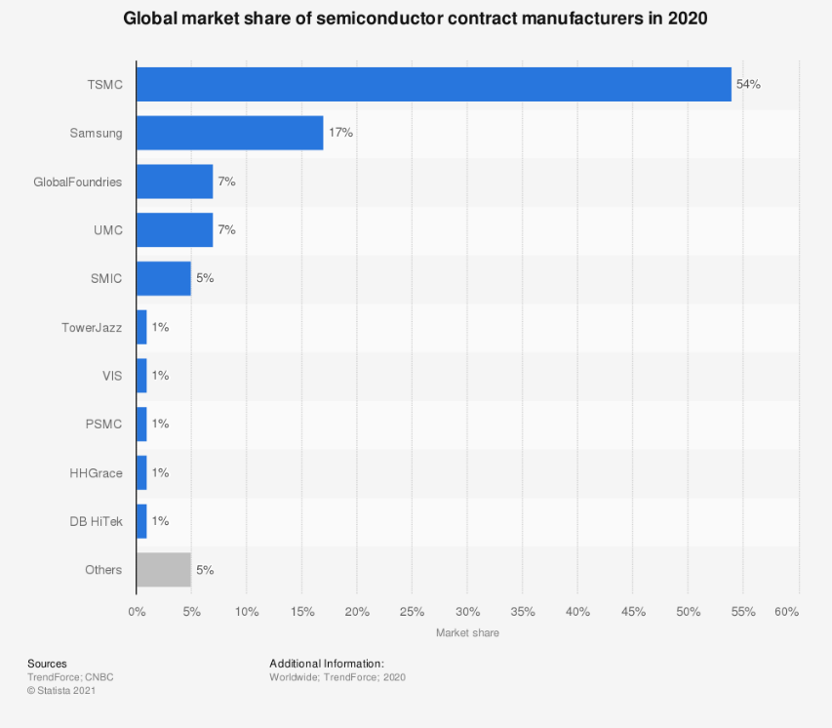Figure 5
Taiwanese foundries, as the world's semiconductor epicenter, control 63 percent of the global market, as shown in Figure 5. Taiwanese foundries such as TSMC, UMC, PSMC, and Vanguard International Semiconductor Corporation (VIS) are responsible for the country's significant market control. TSMC accounts for 54 percent of the total. Figure 5 also shows that TSMC is not the only major Taiwanese chip making company. UMC is also a major player in the semiconductor manufacturing industry, making up seven percent of the global market share of semiconductor contract manufacturers in 2020. A market share that is on par with GlobalFoundries, which is a leading United States foundry. This astounding level of competitiveness for chip manufacturing demonstrates the country’s control over the industry.
Given the fact that TSMC accounts for 54 percent of the foundry market control, it should come as no surprise that the company's clients include a number of well-known companies. Figure 6 displays TSMC’s leading customers in 2021, based on revenue share.
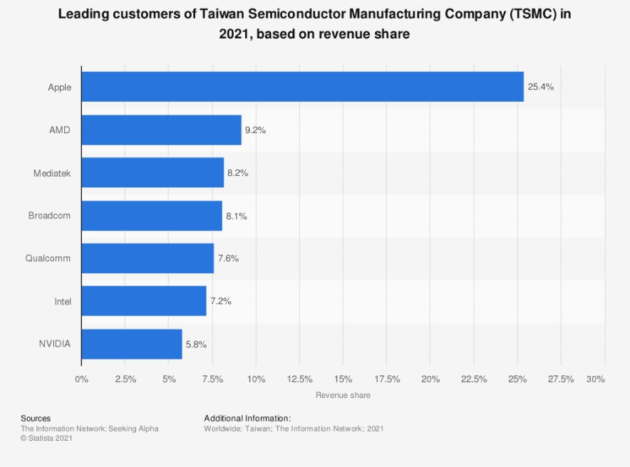Figure 6
As Figure 6 illustrates, some of TSMC's largest customers are also its competitors. Self-sufficiency is a major goal for most countries attempting to improve their position in the semiconductor industry, but it is exceedingly difficult to achieve. One reason Intel is eager to establish its own foundries and become self-sufficient is to eliminate the need to purchase from TSMC. Furthermore, AMD, Broadcom, Qualcomm, and NVIDIA, Intel's main competitors, are major TSMC customers. As shown in Figure 6, they account for 9.2 percent, 8.1 percent, 7.6 percent, and 5.8 percent, respectively, of TSMC's leading customer revenue shares in 2021. AMD founded GlobalFoundries in 2009 but sold their stake in the company in 2012. They now rely heavily on TSMC.
There are a lot of the moving parts and challenges involved with semiconductor manufacturing. Because of this, many countries are struggling to achieve semiconductor self-sufficiency. Nonetheless, these countries are still trying. In its new five-year plan, China declared chip independence a top national objective, while US President Joe Biden pledged to rebuild a secure American supply chain by boosting domestic manufacturing. Even the European Union is considering taking steps to manufacture its own chips. However, success is far from certain. As previously mentioned, China is unable to become self-sufficient as a result of the ban preventing the country from obtaining the necessary equipment. America’s main semiconductor company, Intel has struggled for years now as a result of its expertise falling behind that of their competition, TSMC. Lastly, Europe is having trouble just breaking into the industry.
The Complexities of the Industry
To understand the issue of the global chip shortage, or “crisis”, and the race for dominance in the semiconductor manufacturing industry, appreciating how they are made is important. As previously stated, chips are manufactured in foundries. However, not every company possesses the cutting-edge technology, funds, and resources required to successfully manufacture all semiconductors. The semiconductor industry is highly segmented, necessitating a high level of specialization. Chipsets are designed and marketed by fabless companies, which do not produce their own chips. Another industry segment, only tests finished goods and organizes the packaging process. Finally, semiconductors and chipsets are manufactured by foundries, which are companies that manufacture chips in a fabrication plant (fab). The process of chip manufacturing is incredibly complex and expensive to say the least. It takes years and billions of dollars to develop semiconductor fabrication facilities, and even then, the economics are so cutthroat that even if a company’s manufacturing expertise is a fraction behind the competition, they could lose out. Chipmakers strive to pack more transistors into chips to improve performance and reduce power consumption. This correlates well with the concept of Moore’s Law. According to this law, the number of transistors on a microchip doubles every two years, while the cost of computers is cut in half. Moore's Law also suggests that the rate of increase of microprocessors is exponential. In 1971, Intel released the 4004, a microprocessor with only 2,300 transistors and a node size of 10 microns (ten millionths of a meter). However, Intel's unrivaled dominance in subsequent decades ended between 2015 and 2020, when rivals TSMC and Samsung Electronics Co. began producing chips with smaller transistors, down to 5 nanometers (or 5 billionths of a meter) (for comparison, an average human hair is 100,000 nanometers wide).
How Chips are Manufactured
Every computer has a chip, which is a complex component that serves as the device's central processing unit. Although chips appear to be flat, they are three-dimensional structures with up to 30 layers of complex circuitry and up to 100 layers of material. They take over three months to produce, and massive factories, dust-free environments, multimillion-dollar machinery, molten tin, and lasers are all required for chip manufacturing. Chips vary in size and sophistication depending on the application and function for which they are designed.
Chip production takes place within clean rooms that are thousands of times more sanitary than operating rooms in hospitals. Individual transistors are orders of magnitude smaller than viruses. As a result, a speck of dust can wreak havoc and waste millions of dollars in effort. Clean rooms are required to mitigate this risk. Because sterility is so important in chip manufacturing, fab technicians wear special suits called bunny suits that are designed to keep impurities such as lint and hair off wafers while chip production is taking place on them. Aside from the extreme cleanliness that is needed, special lighting is necessary as well. Photolithography requires yellow lighting in clean rooms to prevent photoresist from being exposed to shorter wavelength light. Photolithography, also known as optical or UV lithography, is a microfabrication technique used to pattern parts on a thin film or the entire surface of a substrate (also called a wafer). Light is used to transfer a geometric pattern from a photomask (also known as an optical mask) to a photosensitive (light-sensitive) chemical photoresist on the substrate. After that, a series of chemical treatments either etches the exposure pattern into the material or allows the deposition of a new material in the required pattern onto the material beneath the photoresist. In complex integrated circuits, a Complementary metal–oxide–semiconductor (CMOS) wafer may go through the photolithographic cycle up to 50 times. Yellow filters essentially remove light-rays that are harmful to the process.
Chips are manufactured in batches of wafers. Silicon is purified, melted, and cooled to form an ingot or a boule, which is then cut into wafer-thin discs. At the same time, chips are built in a grid formation on the wafer surface. The ultimate goal is to convert silicon wafers—an element extracted from ordinary sand—into a network of billions of tiny switches known as transistors, which will serve as the circuitry's foundation. Other metals, such as aluminum, copper, and gold, are added to the chip to improve its capabilities in addition to the silicon that the wafers are made of. Many microchips are only a few millimeters thick and two to three millimeters square. The actual circuit design is drawn onto the chip using ultraviolet light and a stencil, or mask. The design is then completed by the addition of wiring and transistor components. Multiple layers of interconnected, built-in components make up complex integrated circuits. Microchips' data storage and manipulation capabilities are controlled by these built-in transistor components. A basic chip can have up to 3,000 transistors.
Silicon wafer sizes have gradually expanded over the last 50 years, from half-inch and one-inch silicon to more recent six-inch and eight-inch (200mm) silicon, and finally to today's twelve-inch (300-mm diameter) wafers. Wafer size increase has historically been driven by three factors: increasing chip size, increasing chip demand, and the greater chip throughput (and thus cheaper chip cost) that larger wafer sizes provide. The amount of chips manufactured today, as well as the wafer size used, varies. Larger wafers, 300mm and eventually 450mm, necessitate the use of expensive, cutting-edge equipment. To convert the fab from being set up to run 200mm wafers to being set up to run 300mm wafers, all of the equipment must be replaced, and the whole setup of the fab must be altered, all of which costs billions of dollars. Companies would lose a lot of money if they produced anything less than the highest-grade chips due to how expensive the equipment for large wafers are.
The automotive industry requires less advanced, lower cost chips than today's high-end goods, such as computer server chips, that call for the most advanced and costly processor chips. In theory, chipmakers could be doing more to combat the automotive chip shortage and keep up with demand if they made these simpler chips on a larger wafer. It is highly unlikely that Companies like TSMC would carry out such plans because they would lose significant margin if they doubled down on the production of low-cost chips on the most expensive machines. It should be noted that even if chip manufacturers began producing automotive chips on large wafers, the chip shortage is still unlikely to end any sooner. The demand for the more expensive chips produced on 300mm wafers is also very high, so the only real change that would result from this reallocation of resources would be that the chip shortage might simply shift which industry is negatively affected the most rather than solving the problem. Figure 7, as seen below, displays the distribution of semiconductor demand by end use worldwide from 2018 to 2020.
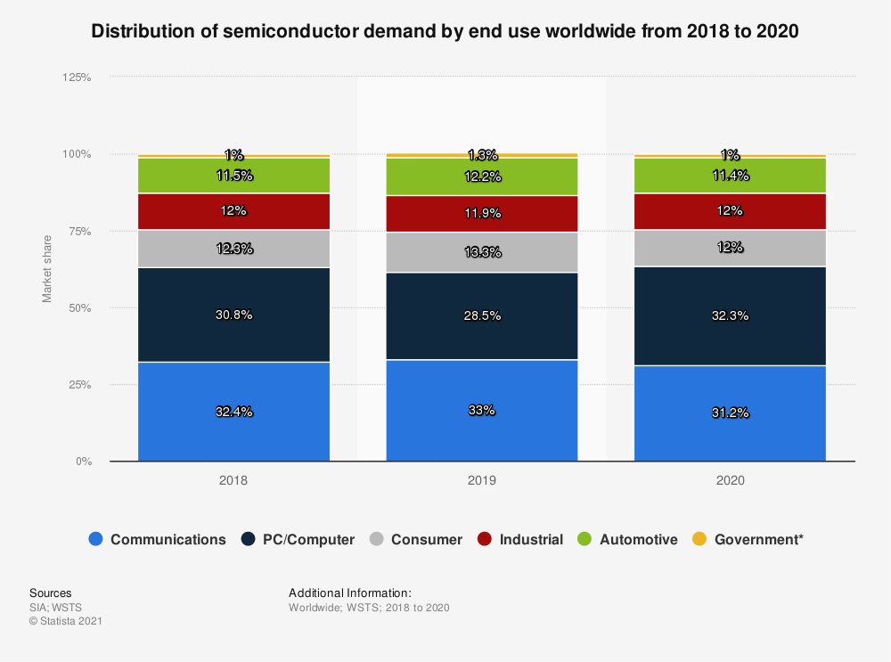Figure 7.
As Figure 7 Illustrates, chips for pc/computers are in even higher demand than automotive chips. Reallocating resources to help meet the automotive industries demand could have negative effects on the industries that require the more complex chips. Still, how detrimental this chip crisis has been for the automotive industry cannot be overstated. When all is said and done, the global auto industry will crank out 4 million fewer vehicles this year than planned and forfeit $110 billion in sales.
COVID demonstrated that the global chip supply chain is fragile and unable to respond quickly to changes in demand. One reason is that fabs are extremely costly to build, furnish, and maintain. Chip plants operate 24 hours a day, seven days a week to meet the demand required to offset the enormous cost of chip manufacturing equipment, a market that exceeded $60 billion in sales for the first time in 2020, as well as the fab itself. An entry-level factory produces 50,000 wafers per month. During a 60 Minutes interview, when asked how much a Fab cost, Intel CEO Pat Gelsinger replied, "$10 billion." He expanded on his claim, stating that each of these pieces of equipment is worth around $5 million; that is a large sum of money. The equipment required for semiconductor manufacturing is highly expensive. Furthermore, depending on the production methods used, a large amount of equipment is required.
From the time silica is used as an input to grow ultrapure, single-crystal ingots from which wafers are taken, to the time integrated circuits built on these wafers are shipped to customers, the process of manufacturing integrated circuits is so complex that it may involve more than 50 different pieces of semiconductor equipment. The equipment’s level of sophistication, definitely plays a part in determining the extremity of equipment expense. One piece of machinery that possibly best proves this point are extreme ultraviolet lithography (EUV) machines. The complex process behind photolithography was touched upon earlier. However, it should be noted that not every lithography system has the same EUV capabilities. It was also previously noted that ASML’s EUV machine, is one of the most cutting-edge machines in the semiconductor manufacturing industry. This relatively new technology was introduced for high-volume manufacturing a few years ago. Still, these machines are rare, DUV (deep ultraviolet) is still the workhorse of the industry. ASML's EUV machine is so rare that each one is said to have over 100,000 parts and requires 40 freight containers or four jumbo jets to ship. According to its financials, ASML sold only 31 of these massive pieces of equipment last year (2020). It has sold more than 100 machines in total. As one would expect, the EUV machine is incredibly expensive, being sold at $140 million per machine.
How the Shortage began
Given the ongoing issues and evolving nature of this “Global Chip Crisis”, understanding how this problem began in the first place is imperative. Because modern life is almost entirely reliant on computers and microchips, semiconductors are required in almost every aspect of it. However, because Taiwan accounts for a large portion of semiconductor production, supply chains are extremely fragile, and even minor disruptions can have a significant impact on global production. When COVID-19 broke out, automakers shut down their production lines, canceling their chip orders as a result. Furthermore, as the demand for personal computers and other electronic devices grew, so did the need for chip makers to focus on meeting these orders. Changing the type of chips produced by a Fab becomes challenging. It is a time-consuming process, and reverting is difficult. Overall, the epidemic significantly disrupted international supply chains. The automobile industry and others attempted to restart production but were unable to do so due to a scarcity of sufficient quantities of microchips. A chip shortage in the automotive industry is a serious problem because a typical new car requires more than a thousand chips. As a result, the initial global chip crisis began.
How the problem has changed
The global chip shortage may have begun as a problem affecting only the automotive industry, but chip manufacturers have since faced increased pressure to meet supply commitments as demand for electronic devices has increased, as has the demand for a broader range of semiconductor applications. Global semiconductor sales totaled more than 40 billion US dollars in the first month of 2021, a 13 percent increase over the same month in 2020. Climate change and the resulting extreme weather events, as well as geopolitical tensions such as the China–United States trade war, are not new problems for the semiconductor manufacturing industry; however, the increasing severity of the issues, combined with the already existing chip shortage, has resulted in increased chip demand and chip stockpiling.
The semiconductor manufacturing industry is starting to feel the effects of climate change more consistently. The industry is truly in a “catch-22” situation. On the one hand, semiconductors will play a role in meeting global climate goals. They are required components in electric vehicles, solar arrays, and wind turbines. In contrast, chip manufacturing also contributes to the climate crisis. It consumes a large amount of energy and water – a chip fabrication plant, or fab, can consume millions of gallons of water per day – and generates hazardous waste. The energy transition will not be successful without chips, but the carbon footprint, in addition to wasted energy and resources, has become a major issue.
Drought and water stress are two issues that are frequently overlooked in the semiconductor industry. Because chip production necessitates a massive supply of ultra-purified water, this problem has become increasingly severe. Water is required for the removal of particles and chemicals from chip surfaces. In 2019, TSMC alone used nearly 63 million tons of water. During this year's severe drought in Taiwan, the country's worst in 50 years, the company's water usage became a source of contention, pitting chipmakers against farmers. In 2020-2021, Taiwan experienced its worst drought in 56 years as a result of unusual weather patterns. Total precipitation (807 millimeters) was only about one-third of the annual average from June 2020 to May 19, 2021, exacerbating the region's water-withdrawal conflicts. All of Taiwan's 12 reservoirs that serve as primary water sources for chipmakers have seen dwindling water levels since June 2020, with total capacity falling to 5.38 percent of total capacity as of May 25, 2021, a record low. Figure 8 displays the severe drought that took place this year in Taiwan.
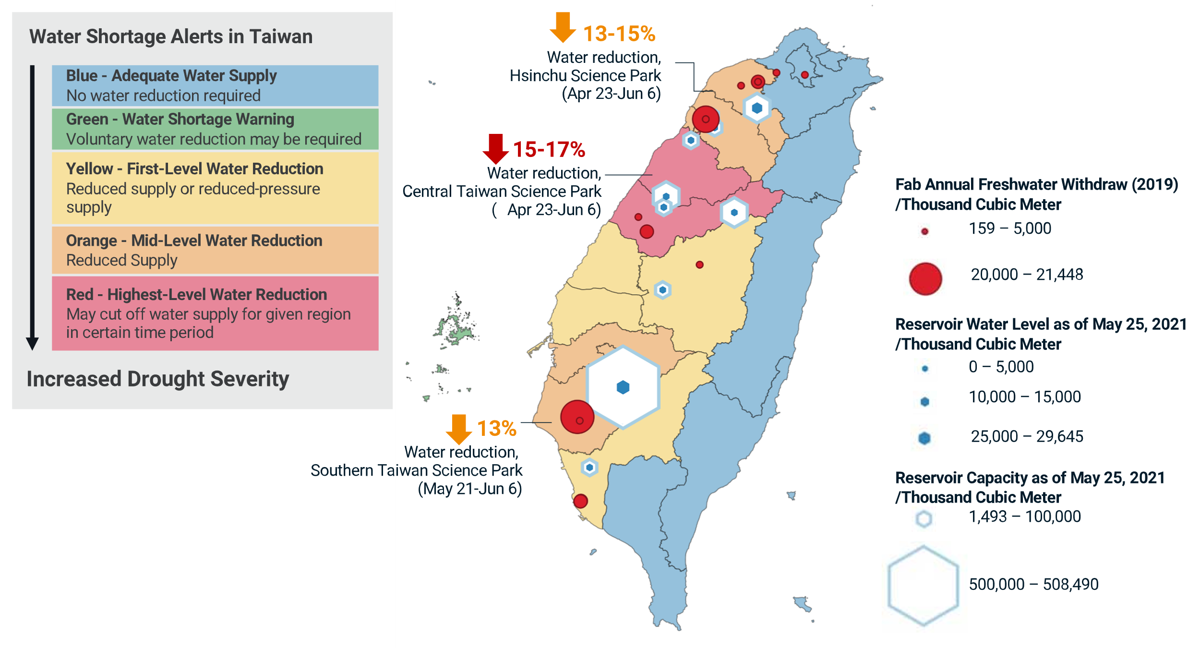
As illustrated in Figure 8, all of the reservoirs have suffered as a result of the drought, and it has been an ongoing struggle to produce the necessary water supply for chip production, let alone the rest of the country's needs. Aside from the water shortage, the chip industry's large carbon footprint, as well as wasted energy and resources, has caused controversy about how chip manufacturers should conduct production.
Even before the coronavirus outbreak in 2020, President Donald Trump's trade policies reduced the number of semiconductors available in the United States. As part of his “trade war” with China in 2018, Trump imposed 25 percent tariffs on $34 billion in Chinese imports, including semiconductors. This was just the first of several shots fired in Trump's trade war with China. Tariffs remain in place, and Chinese chip imports have decreased by half. According to the research firm Panjiva, China currently accounts for about five percent of U.S. imported semiconductors. Imports from other countries, however, have not increased to compensate for the loss of Chinese supply.
During a shortage, a five percent reduction in supplies could have far-reaching consequences. This was unequivocally proven to be the case. According to Reuters, one automaker was forced to shift chip manufacturing from China’s SMIC to Taiwan’s TSMC, which was already overbooked, after SMIC was subjected to US government restrictions in December. Because doing business with China was no longer an option, automakers and other technology firms had to look elsewhere for their chips. TSMC is the most logical alternative because it supplies the majority of the world's semiconductors; however, they have been unable to keep up with the surge in demand. "The systemic aspect of the crisis is giving us a headache," said an auto supplier executive who requested anonymity. "In some cases, we find substitution parts that could make us independent of TSMC, only to discover that the alternative wafer manufacturer has no capacity available".
Another result of the trade war was the Trump administration's effort to disenfranchise Huawei, which included a 2019 ban on the sale of American-made components, including semiconductors, to Huawei. This measure, according to the U.S. semiconductor industry, made it harder for American companies to sell their products. Huawei, who happens to be one of the top customers in the American chip industry, has cost them millions of dollars in sales. The policy decision did, however, have an advantage. HiSilicon, a Huawei-owned company, accounted for approximately 13 percent of TSMC’s revenue until 2020; by 2021, the company was no longer a customer. In 2019, Huawei was added to the United States government's entity list, limiting the scope of companies that could engage with Huawei. Although this could be seen as a loss of business for TSMC, given how overbooked the company would become as result of the chip crisis, one less major customer to worry about supplying for probably helped them a little.
Regardless of any potential benefits from the trade war, the world is currently experiencing a global chip shortage as well as a pandemic. The disadvantages far outweigh the advantages. Huawei was one of the largest consumers of American-made semiconductors, and SMIC supplied chips to a number of automotive and technology companies. Even though, once the chip shortage began, the restrictions imposed on HiSilicon reduced the demand that TSMC needed to meet, the Taiwanese chip manufacturer saw no real benefit from it. Soon, automotive and technology companies that could no longer do business with SMIC would turn to TSMC and other manufacturers for their chips. As a result, TSMC and other chip manufacturers were and are still unable to meet the increased demand. Jia Shaoqian, president of Hisense Group Holding Company, one of China's largest TV and household goods manufacturers, stated that if there are no major issues with global trade disputes, the chip shortage could be resolved in two to three years; however, it is difficult to predict if trade and economic sanctions continue.
US-Taiwan Trade relations
Semiconductors are the backbone of the United States' and China's mutually reliant technological objectives. Semiconductors are also a significant technological vulnerability for both China and the United States, which rely on each other for cutting-edge semiconductor products and equipment, and both also rely heavily on Taiwan. Taiwan is clearly and constantly reliant on the unspoken and unwritten promise of American support since it is constantly threatened by China who claims the tech giant as a sovereign territory that belongs to them. Taiwan is and will remain a focal point of US-China hostilities. Given China's central role in semiconductor manufacturing and technology supply chains, the country may use its economic clout to attack key companies via trade restrictions, talent recruitment, and cyber-attacks in order to obtain core semiconductor intellectual property (IP) needed to support its domestic industry.
Conclusion
This study examined the global chip shortage as well as the race for technological dominance in this multibillion-dollar industry. Semiconductor chip’s utility and criticality appear to be increasing, but as this paper shows, keeping up with demand during a global pandemic has been extremely difficult. This scarcity, and the pandemic in general, has served as a wake-up call. Given the importance and difficulty of responding quickly to changes in demand, it is astonishing that the international community has not done more to ensure the security and stability of the global chip supply chain. The fact that the rest of the world cannot keep up with Taiwan is a major factor in the onset and continuation of this shortage. Taiwan is so vital to the semiconductor industry that if China were to invade the country, the international community, led by the United States, would almost certainly come to their aid. Taiwan has been able to provide itself with security as a result of its necessity by wielding such a large amount of influence over this industry. This has been beneficial to them, but it has also proven to be a burden for them, as they are the only country with their level of chip production capabilities. This has also become a security risk for the rest of the world, as countries have begun to realize how vulnerable they are by not being able to provide for themselves when needed.
There is no telling how long this scarcity will last. It could take another year, or even three. There are many unanswered questions in this evolving industry, but a few in particular stand out. What will happen to the semiconductor industry if and when North American and Chinese foundries catch up to Taiwan? How likely, and how damaging, would China's threat to Taiwanese sovereignty be? Is this crisis, as well as the planned shifts away from Taiwan, reducing globalization and causing irreversible damage to major economies? Finally, has the global automotive industry learned anything from this crisis; will they reconsider their supply chains and address this vulnerability?

Bibliography
Alsop, Thomas. “Global Chip Shortage 2021 - Statistics & Facts.” Shibboleth authentication request, April 26, 2021. https://www-statista-com.unh-proxy01.newhaven.edu/topics/7797/global-chip-shortage/#dossierKeyfigures.
Alsop, Thomas. “Semiconductor Expenditure of Technology Companies Worldwide 2014-2020.” Shibboleth authentication request, April 23, 2021. https://www-statista-com.unh-proxy01.newhaven.edu/statistics/383157/technology-companies-semiconductor-expenditures-ranking/.
Alsop, Thomas. “Semiconductor Industry Revenue Worldwide from 2012 to 2020.” Shibboleth authentication request, November 23, 2021. https://www-statista-com.unh-proxy01.newhaven.edu/statistics/272872/global-semiconductor-industry-revenue-forecast/.
Alsop, Thomas. “Semiconductor Industry Sales Worldwide 1987-2022.” Shibboleth authentication request, December 13, 2021. https://www-statista-com.unh-proxy01.newhaven.edu/statistics/266973/global-semiconductor-sales-since-1988/.
Alsop, Thomas. “Top Semiconductor Companies by Revenue 2014-2020.” Shibboleth authentication request, October 27, 2021. https://www-statista-com.unh-proxy01.newhaven.edu/statistics/283359/top-20-semiconductor-companies/.
Analytics, FP. “Semiconductors and the U.S.-China Innovation Race.” Foreign Policy. Foreign Policy, February 16, 2021. https://foreignpolicy.com/2021/02/16/semiconductors-us-china-taiwan-technology-innovation-competition/.
Belton, Pádraig. “The Computer Chip Industry Has a Dirty Climate Secret.” The Guardian. Guardian News and Media, September 18, 2021. https://www.theguardian.com/environment/2021/sep/18/semiconductor-silicon-chips-carbon-footprint-climate.
Chang, Yanrong. “A Taiwanese Perspective on the Semiconductor Industry: Maintaining the Competitive Edge.” EIAS, August 27, 2021. https://eias.org/op-ed/a-taiwanese-perspective-on-the-semiconductor-industry-maintaining-the-competitive-edge/.
EESemi.com. Semiconductor Manufacturing Equipment, 2004. https://eesemi.com/semicon_eqpt.htm.
Gartner, and Design & Reuse. “Technology Companies Ranked by Expenditure on Semiconductors Worldwide from 2014 to 2020.” Shibboleth authentication request, February 2021. https://www-statista-com.unh-proxy01.newhaven.edu/statistics/383157/technology-companies-semiconductor-expenditures-ranking/.
Guo, Siping. “Powering Better Investment Decisions.” MSCI, November 9, 2021. https://www.msci.com/.
Horiba Semiconductor. “Semiconductor Processing: Photolithography.” Semiconductor Processing: Photolithography, 2021. https://www.horiba.com/gbr/semiconductor/applications/photolithography/.
The Information Network, and Seeking Alpha. “Leading Customers of Taiwan Semiconductor Manufacturing Company (TSMC) in 2021, Based on Revenue Share.” Shibboleth authentication request, March 2021. https://www-statista-com.unh-proxy01.newhaven.edu/statistics/1247996/tsmc-revenue-share-of-leading-customers/.
Intel. “Silicon Chips: What Are Computer Chips Made of?” Intel. Accessed December 17, 2021. https://www.intel.com/content/www/us/en/history/museum-making-silicon.html.
Jeanty, Jacquelyn. “How Does a Microchip Work?” Techwalla. Accessed December 17, 2021. https://www.techwalla.com/articles/how-does-a-microchip-work.
Kharpal, Arjun. “Chip Shortage Could Persist for Another 2 to 3 Years, Major Chinese Consumer Goods Maker Warns.” CNBC. CNBC, October 15, 2021. https://www.cnbc.com/2021/10/15/chip-shortage-could-persist-for-another-2-3-years-hisense-president.html.
King, Ian, Adrian Leung, and Demetrios Pogkas. “The Chip Shortage Keeps Getting Worse. Why Can't We Just Make More?” Bloomberg.com. Bloomberg, May 6, 2021. https://www.bloomberg.com/graphics/2021-chip-production-why-hard-to-make-semiconductors/.
King, Ian. “Intel Spending Billions to Revive Manufacturing, Chase TSMC.” Bloomberg.com. Bloomberg, March 23, 2021. https://www.bloomberg.com/news/articles/2021-03-23/intel-to-spend-billions-on-manufacturing-revival-taking-on-tsmc.
Klayman, Ben, and Stephen Nellis. “Trump's China Tech War Backfires on Automakers as Chips Run Short.” Reuters. Thomson Reuters, January 15, 2021. https://www.reuters.com/article/us-autos-tech-chips-focus/trumps-china-tech-war-backfires-on-automakers-as-chips-run-short-idUSKBN29K0GA.
Lee, Yen Nee. “2 Charts Show How Much the World Depends on Taiwan for Semiconductors.” CNBC. CNBC, March 16, 2021. https://www.cnbc.com/2021/03/16/2-charts-show-how-much-the-world-depends-on-taiwan-for-semiconductors.html.
Lisa, Andrew. “4 Critical Industries Affected by the Chip Shortage.” Yahoo! Yahoo!, August 24, 2021. https://www.yahoo.com/now/4-critical-industries-affected-chip-013610213.html.
Mack, Chris. “Why 450mm Wafers?” Semiconductor Engineering, August 8, 2012. https://semiengineering.com/450mm-wafers/.
Newman, Rick. “How Trump Worsened the Semiconductor Shortage.” Yahoo! News. Yahoo!, July 7, 2021. https://news.yahoo.com/how-trump-worsened-the-semiconductor-shortage-192026179.html.
Schoolov, Katie. “How Intel Plans to Catch Samsung and TSMC and Regain Its Dominance in the Chip Market.” CNBC. CNBC, November 6, 2021. https://www.cnbc.com/2021/11/06/how-intel-plans-to-catch-up-to-samsung-and-tsmc-with-44-billion-of-new-global-chip-fabs.html.
Shead, Sam. “Investors Are Going Wild over a Dutch Chip Firm. and You've Probably Never Heard of It.” CNBC. CNBC, November 24, 2021. https://www.cnbc.com/2021/11/24/asml-the-biggest-company-in-europe-youve-probably-never-heard-of.html.
SIA, and Semiconductor Equipment and Materials International. “Semiconductor Equipment Spending Worldwide from 2008 to 2020, by Region.” Shibboleth authentication request, April 2021. https://www-statista-com.unh-proxy01.newhaven.edu/statistics/792613/worldwide-semiconductor-equipment-spending-market-region/.
SIA, and WSTS. “Distribution of Semiconductor Demand by End Use Worldwide from 2018 to 2020.” Shibboleth authentication request, May 2021. https://www-statista-com.unh-proxy01.newhaven.edu/statistics/894267/semiconductor-market-share-worldwide-by-end-use/.
SIA, and WSTS. “Semiconductor Market Size Worldwide from 1987 to 2022.” Shibboleth authentication request, November 2021. https://www-statista-com.unh-proxy01.newhaven.edu/statistics/266973/global-semiconductor-sales-since-1988/.
Slotta, Daniel. “Global: Market Share of Leading Semiconductor Manufacturers 2020.” Statista, July 9, 2021. https://www.statista.com/statistics/1246563/global-market-share-of-leading-semiconductor-manufacturers/.
Slotta, Daniel. “Revenue Share of Major Customers of TSMC 2021.” Shibboleth authentication request, July 9, 2021. https://www-statista-com.unh-proxy01.newhaven.edu/statistics/1247996/tsmc-revenue-share-of-leading-customers/.
Slotta, Daniel. “Taiwan Semiconductor Manufacturing Company - Statistics & Facts.” Shibboleth authentication request, July 26, 2021. https://www-statista-com.unh-proxy01.newhaven.edu/topics/7097/taiwan-semiconductor-manufacturing-company/#dossierKeyfigures.
Stahl, Lesley. “Chip Shortage Highlights U.S. Dependence on Fragile Supply Chain.” CBS News. CBS Interactive, August 29, 2021. https://www.cbsnews.com/news/semiconductor-chip-shortage-60-minutes-2021-08-29/.
Tardi, Carla. “Moore's Law Explained.” Investopedia. Investopedia, October 4, 2021. https://www.investopedia.com/terms/m/mooreslaw.asp.
TSMC. “Distribution of Net Profit of Taiwan Semiconductor Manufacturing Company in 2020, by Region.” Shibboleth authentication request, April 2021. https://www-statista-com.unh-proxy01.newhaven.edu/statistics/1177844/taiwan-semiconductor-manufacturing-company-share-of-net-income-by-region/.

Alsop, Thomas. “Semiconductor Industry Revenue Worldwide from 2012 to 2020.” Shibboleth authentication request, November 23, 2021.
Chang, Yanrong. “A Taiwanese Perspective on the Semiconductor Industry: Maintaining the Competitive Edge.” EIAS, August 27, 2021.
Alsop, Thomas. “Semiconductor Industry Sales Worldwide 1987-2022.” Shibboleth authentication request, December 13, 2021.
SIA, and WSTS. “Semiconductor Market Size Worldwide from 1987 to 2022.” Shibboleth authentication request, November 2021.
TSMC. “Distribution of Net Profit of Taiwan Semiconductor Manufacturing Company in 2020, by Region.” Shibboleth authentication request, April 2021.
TSMC. “Distribution of Net Profit of Taiwan Semiconductor Manufacturing Company in 2020, by Region.” Shibboleth authentication request, April 2021.
Alsop, Thomas. “Semiconductor Expenditure of Technology Companies Worldwide 2014-2020.” Shibboleth authentication request, April 23, 2021.
Gartner, and Design & Reuse. “Technology Companies Ranked by Expenditure on Semiconductors Worldwide from 2014 to 2020.” Shibboleth authentication request, February 2021.
Stahl, Lesley. “Chip Shortage Highlights U.S. Dependence on Fragile Supply Chain.” CBS News. CBS Interactive, August 29, 2021.
King, Ian. “Intel Spending Billions to Revive Manufacturing, Chase TSMC.” Bloomberg.com. Bloomberg, March 23, 2021.
Stahl. “Chip Shortage Highlights U.S. Dependence on Fragile Supply Chain.”
Schoolov, Katie. “How Intel Plans to Catch Samsung and TSMC and Regain Its Dominance in the Chip Market.” CNBC. CNBC, November 6, 2021.
Alsop, Thomas. “Top Semiconductor Companies by Revenue 2014-2020.” Shibboleth authentication request, October 27, 2021.
SIA, and Semiconductor Equipment and Materials International. “Semiconductor Equipment Spending Worldwide from 2008 to 2020, by Region.” Shibboleth authentication request, April 2021.
Slotta, Daniel. “Taiwan Semiconductor Manufacturing Company - Statistics & Facts.” Shibboleth authentication request, July 26, 2021.
Lee, Yen Nee. “2 Charts Show How Much the World Depends on Taiwan for Semiconductors.” CNBC. CNBC, March 16, 2021.
Ibid.
Slotta. “Taiwan Semiconductor Manufacturing Company - Statistics & Facts.”
Slotta, Daniel. “Global: Market Share of Leading Semiconductor Manufacturers 2020.” Statista, July 9, 2021.
Slotta. “Taiwan Semiconductor Manufacturing Company - Statistics & Facts.”
The Information Network, and Seeking Alpha. “Leading Customers of Taiwan Semiconductor Manufacturing Company (TSMC) in 2021, Based on Revenue Share.” Shibboleth authentication request, March 2021.
King, Ian, Adrian Leung, and Demetrios Pogkas. “The Chip Shortage Keeps Getting Worse. Why Can't We Just Make More?” Bloomberg.com. Bloomberg, May 6, 2021.
Slotta. “Taiwan Semiconductor Manufacturing Company - Statistics & Facts.”
King. “The Chip Shortage Keeps Getting Worse.
Tardi, Carla. “Moore's Law Explained.” Investopedia.
King. “The Chip Shortage Keeps Getting Worse.
Intel. “Silicon Chips: What Are Computer Chips Made of?” Intel. Accessed December 17, 2021.
King. “The Chip Shortage Keeps Getting Worse.
Intel. “Silicon Chips: What Are Computer Chips Made of?”
Horiba Semiconductor. “Semiconductor Processing: Photolithography.” Semiconductor Processing: Photolithography, 2021.
Intel. “Silicon Chips: What Are Computer Chips Made of?”
Jeanty, Jacquelyn. “How Does a Microchip Work?” Techwalla. Accessed December 17, 2021.
Mack, Chris. “Why 450mm Wafers?” Semiconductor Engineering, August 8, 2012.
SIA, and WSTS. “Distribution of Semiconductor Demand by End Use Worldwide from 2018 to 2020.” Shibboleth authentication request, May 2021.
Lisa, Andrew. “4 Critical Industries Affected by the Chip Shortage.” Yahoo! Yahoo!, August 24, 2021.
King. “The Chip Shortage Keeps Getting Worse.
Stahl. “Chip Shortage Highlights U.S. Dependence on Fragile Supply Chain.”
EESemi.com. Semiconductor Manufacturing Equipment, 2004.
Shead, Sam. “Investors Are Going Wild over a Dutch Chip Firm. and You've Probably Never Heard of It.” CNBC. CNBC, November 24, 2021.
Slotta. “Taiwan Semiconductor Manufacturing Company - Statistics & Facts.”
Alsop, Thomas. “Global Chip Shortage 2021 - Statistics & Facts.” Shibboleth authentication request, April 26, 2021.
Belton, Pádraig. “The Computer Chip Industry Has a Dirty Climate Secret.” The Guardian. Guardian News and Media, September 18, 2021.
Pádraig. “The Computer Chip Industry Has a Dirty Climate Secret.” The Guardian.
Guo, Siping. “Powering Better Investment Decisions.” MSCI, November 9, 2021.
Siping. “Powering Better Investment Decisions.” MSCI
Newman, Rick. “How Trump Worsened the Semiconductor Shortage.” Yahoo! News. Yahoo!, July 7, 2021.
Newman. “How Trump Worsened the Semiconductor Shortage.”
Klayman, Ben, and Stephen Nellis. “Trump's China Tech War Backfires on Automakers as Chips Run Short.” Reuters. Thomson Reuters, January 15, 2021.
Ibid.
Newman. “How Trump Worsened the Semiconductor Shortage.”
Slotta, Daniel. “Revenue Share of Major Customers of TSMC 2021.” Shibboleth authentication request, July 9, 2021.
Kharpal, Arjun. “Chip Shortage Could Persist for Another 2 to 3 Years, Major Chinese Consumer Goods Maker Warns.” CNBC. CNBC, October 15, 2021.
Analytics, FP. “Semiconductors and the U.S.-China Innovation Race.” Foreign Policy. Foreign Policy, February 16, 2021.

